MadMath Idle
  - Jenul Ferdinand

Description
I’m going to maintain and progress my project from the SDLC Mental Maths Builder task. A game where you can solve simple math questions to get high scores. More details in my GitHub repository about this project (https://github.com/proxgithub/mental-maths-builder).
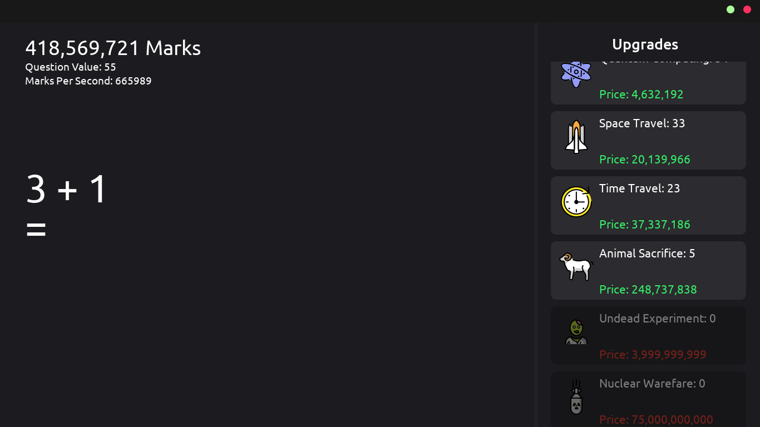
The state of the game currently looks like this. For this major project I will add more features and fix bugs to make the game enjoyable and engaging for the players.

Inspiration
Inspired by the game Cookie Clicker by Orteil, this takes a different approach. Instead of clicking cookies, you solve simple maths questions to earn marks which you can spend on upgrades.

Problem Statement
This game will help people improve their mental math skills in a fun way. This could also help kids improve their math skills much quicker since it is fun and addicting.

Objectives
- Typing Bugfixes
- Saving & Loading
- Quality of Life Improvements
- Achievements
- Settings Menu

Resources
- Game Maker Studio 2 (Engine)
- GitHub (Version Control)
- Photoshop CC (Designing)

Alternatives
An alternative project I was thinking of creating was a study aid website, containing a pomodoro and relaxing full screen video. Which the user can change, essentially a replica of lifeat.io. But I want to make something original, so this is a backup idea.

